Dear Parents/Carers,
Our children continue to settle well into their new classes and I have been delighted to receive so many visits from children wishing to share excellent examples of work. It is so lovely to see children really trying their best.

Reception children stayed for lunch for the first time this week and are adapting extremely well to school life. Every year we forget just how much there is to learn and how exhausting it can be when you are 4 or 5 years old. Reception teachers have very tired voices!!
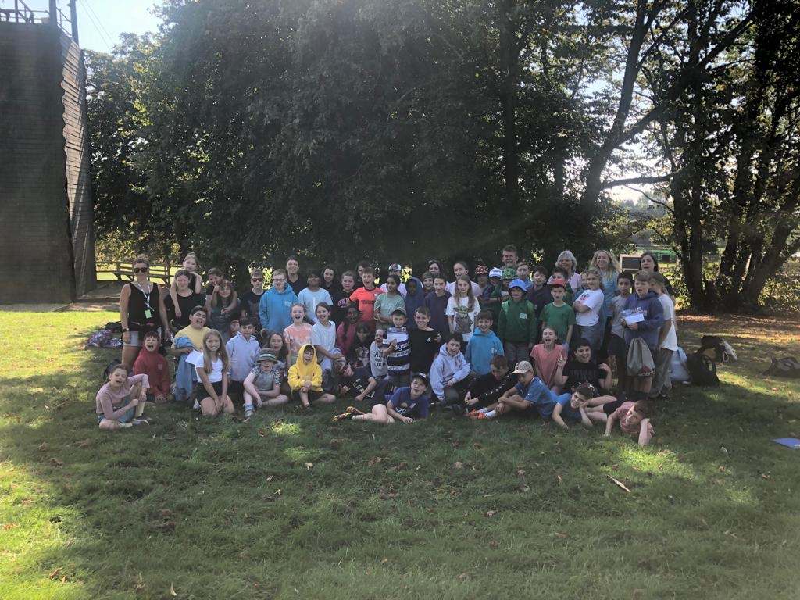
Our oldest pupils are currently at PGL Windmill Hill in Hailsham, enjoying their 3 day residential trip. We moved it to earlier in the academic year to keep the cost down and to help children and staff get to know each other in a fun setting. Communications from camp have let us know that there is some sleeping and lots of resilience being shown as children challenge themselves to try new activities.

Our London Meed Association met for the first time this academic year on Monday evening. Please see below for their report of the meeting and details of forthcoming events. Do remember that you are all members of the LMA and we welcome your support in whatever way you can provide it.

‘Meet the teacher’ session start next week, please see the table below for dates that you are invited into school for particular year groups. The playground gates will be opened at 2.50pm ready for the meetings to start at 2.55pm.
I would like to remind you that our school policy is that children should not bring in items from home, including sentimental items, as there is such a high risk of them being lost or damaged (this does not include parents who have a prior agreement with Mr Viinikka or Ms Palethorpe). We would appreciate your cooperation with this.
Clubs will start back next week. Turner Tennis sessions filled up extremely quickly for Years 3 and 4. Children who wanted a place but didn't get one will be on a waiting list. Please ensure that you notify the school office via mailto:office@londonmeedprimary.co.uk if your child is not able to attend for any reason or they no longer wish to participate as we will then offer a place to the next person on the waiting list.

Have a really lovely weekend everyone.

Kindest regards,
Natalie Langtree, Head teacher

LMA News
Thank you to all the new faces who came to our first meeting of this school year and I hope we didn't put you off with how much we discussed.
Our first meeting is always about trying to make a plan for the year, and this can be quite daunting. There's a lot of ideas out there, some that we haven't tried and some that we have. While we would love to be able to create all the suggestions into physical events, in reality, without volunteers, we just can't make it happen.
The purpose of the LMA is to try and fill the gaps that the budgets can't. We are here to provide extra equipment, extra luxuries, extra anything really, within reason. But the only way we can do this is with help!
It would be really great if at the start of term, parents and members of the school community could commit to us in some way. Whether it be helping at an event, or helping organise an event, providing us with suggestions and feedback or even just donations, prizes, food, or just plain old money. We really appreciate everything that comes our way.
With that in mind, can I make my first plea of the year please?... Second hand uniform!! If you have any lying around that you can donate, especially reception sized, please could you.Donations can be left at the school office. We are making some changes in the coming weeks to the way this can be passed back to the school community and donations are always greatly appreciated.
On the 24th September, Burgess Hill will be holding another jumble trail and Alix Bell has kindly offered to have a second hand uniform stall outside her house on Chanctonbury Road (near the school). Hopefully the weather holds out for all those getting involved.
My next plea is about Christmas... The first meeting of the year always coincides with the start of the arrangements for the Christmas Fair, so we have settled on a date of the 2nd December, SAVE THE DATE! Do we have any parents out there who can help in any way with making this year the best yet! Do we have any carpenters? Creative people who can build or design? Bakers? Crafters? If you have any skills at all or even would just like to lend a hand in some way to bring the fair to life please contact me so we can discuss. My email is lma@londonmeedprimary.co.uk
Staying on the Christmas theme, this year we would like the students to get involved with planning. We will be running a competition, details will be sent in due course, whereby the students can design the posters, flyers and theme for the Christmas Fair. There will be prizes and house points on offer and of course the winner will get to see their design advertising the fair itself. Let the children know they can start planning and the details will be sent out shortly.
Thank you again to those that came last night, fresh eyes are always a good thing! If ever you have any suggestions or feedback for us, please feel free to contact us.
Looking forward to another school year, full of fundraising, friends and fun!! Clare and the LMA Team

Meet the Teacher
Our teachers in Years 1-6 are opening up their classrooms to parents/carers for a brief meeting where they will introduce themselves and outline plans for the year ahead. Gates will be open for parents to access the classrooms. Please see the dates below.
Year Group; | Date
Monday 18th September 2.55-3.15pm | Year 6
Tuesday 19th September  2.55-3.15pm | Year 5
Thursday 21st September  2.5 | Year 4
Friday 22nd September  2.55-3.15pm | Year 3
Thursday 28th September  2.55-3.15pm | Year 2
Friday 29th September  2.55-3.15pm | Year 1

Is my child too ill for school?
It can be tricky deciding whether or not to keep your child off school, nursery or playgroup when they're unwell.
There are government guidelines for schools and nurseries about managing specific infectious diseases at GOV.UK. These say when children should be kept off school and when they shouldn't. For more guidance please visit https://www.nhs.uk/live-well/is-my-child-too-ill-for-school/
If you do keep your child at home, it's important to notify the school on the first day before 9.20am to let them know that your child won't be in and give them the reason. You can leave a message on the absence line 01444 232336 or report their absence on the Study Bugs App
If your child is well enough to go to school but has an infection that could be passed on, such as a cold sore or head lice, please let their teacher know via their year group email address.

London Meed loves Reading
Roald Dahl Day is the 13th September 2023.Roald Dahl is best known as one of the world’s best-loved storytellers. In books like “Matilda”, “Charlie and the Chocolate Factory”, and “James and the Giant Peach”, Dahl brought readers into his wildly original imagination with richly detailed worlds, zany characters, and touching storylines. His children’s books feature villainous adults, heroic child protagonists, and fanciful worlds.

Reading Workshops
We are hosting two parent workshops in the large hall in the next couple of weeks.
On Monday 25th September, 2.30-3.15pm, Miss Oliver is hosting a Reading Workshop for parents/carers of children in Years 3-6. The workshop will be about Reading at London Meed and how parents/carers can help their child. To book a place please click the link below
KS2 Reading Workshop booking form
On Tuesday 26th September, 2.30-3.15pm, Mrs Maddock is hosting a
Reading/ Phonics Workshop for parents of children in Reception and Years 1 to 2. To book a place please click the link below:
KS1 Reading/Phonics Workshop
We look forward to seeing you then.
Many congratulations to this week’s London Meed Hero Awards winners.
Name of child | Class | Reason
Macton | 5D | For a positive start to the school year and displaying bravery when taking on new challenges, such as swimming. Well done, Mac!
Isla W | 5S | For showing bravery and resilience when faced with a challenge during swimming lessons.
Anya | 4P | For working conscientiously in all her work and being a great role model in the class.
Riley | 4O | For some writing some great similes and selecting your best vocabulary
Jack | 3M | For always trying his best and using fantastic adjectives to describe Camp WooWoo. Well done!
Alfie | 3C | For listening carefully when controlling a ball and encouraging his peers to do the same.
Harry | 2K | For working so hard this week when writing sentences about castles! You have done so well!
Poppy | 2M | For writing brilliant questions about castles. Well done!
Rosie | 1S | For writing brilliant facts about animals and challenging herself. to do more writing when working independently. Well done!
Molly | 1M | For achieving a London Meed Hero award for her bravery. Molly has come into school independently over the last 2 weeks and has really demonstrated the London Meed values in all that she does. Well done Molly!

Free School Meals
Is my child eligible?
From 1 April 2018, free school meals in all West Sussex maintained and free schools and academies are available to pupils in receipt of, or whose parents are in receipt of, one or more of the following benefits:
- Universal Credit (provided you have an annual net earned income of no more than £7,400, as assessed by earnings from up to three of your most recent assessment periods)
- Income Support
- Income-based Jobseeker's Allowance
- Income-related Employment and Support Allowance
- Support under Part VI of the Immigration and Asylum Act 1999
- The guaranteed element of state Pension Credit
- Child Tax Credit (provided you're not also entitled to Working Tax Credit and have an annual gross income of no more £16,190)
- Working Tax Credit run-on - paid for four weeks after you stop qualifying for Working Tax Credit.
A number of pupils will also be protected against losing their current free school meals. You can find more information on GOV.UK. If you are not eligible for benefits-related, free school meals, but your child is currently in Reception, Year 1 or Year 2, they will automatically be entitled to Universal Infant Free School Meals and you need not apply. Contact your school for details.
If you are eligible for benefits-related free school meals in accordance with the above criteria, and your child is also receiving Universal Infant Free School Meals, please continue to register. This will enable your child's school to claim valuable 'pupil premium' funding.
To apply for Free School Meals please visit
https://www.westsussex.gov.uk/education-children-and-families/schools-and-colleges/free-school-meals/#how-to-apply

Online Safety
Almost half (46%) of 8- to 11-year-olds in the UK play online video games with people that they don’t necessarily know 👤🎮 While 55% of parents of young gamers worry that their child might be pressured into making expensive in-game purchases 💸
Most children find gaming immensely enjoyable, but its volume of potential risks – and capacity to influence behaviour – often make it problematic for parents. The #WakeUpWednesday guide attached suggests some sensible ground rules for promoting safer, healthier gaming habits.

Please remember to send your child in their PE kits on their allocated PE day below. - these are the new days from 4th September 2023

Year Group/Class | PE days
Apples | Wednesday and Thursday
Cherries | Monday and Wednesday
Year 1 | Wednesday and Thursday
Year 2 | Tuesday and Friday
Year 3 | Wednesday and Friday
Year 4 | Monday and Friday
Year 5 | Tuesday and Wednesday
Year 6 | Monday and Thursday

West Sussex Family Hub
There is a Family Hub in Penn Crescent Haywards Heath that is open to all families. Family hubs offer a range of support, information and guidance to parents, carers and young people as part of Early Help.Hubs are open for you to drop in and speak to our staff Monday to Friday during opening times on a whole range of issues affecting you and your family. They also have public access computers to use, free of charge, as well as social spaces available to meet other parents.
in all our hubs on the front desk who can offer information, advice and guidance.
They can help you with:
- finding childcare
- applying for free childcare entitlement
- finding local activities and support services
- pregnancy and early child development
- Parenting and health advice for you and your family
- how to access local housing services
- crisis support, such as emergency access to food and utilities, personal finance and the benefits you may be entitled to.
For further information please click on the link in the title.

Forthcoming events

To view forthcoming diary dates please visit our Online calendar which can be accessed via our website www.londonmeedprimary.co.uk

Term Dates 2023-2024
For WSCC term dates please visit https://www.westsussex.gov.uk/media/15495/school_term_calendar_2022_23_res.pdf

Academic Year 2023-2024 term dates including INSET Days
Autumn Term 2023
INSET DAY - Friday 1st September
Starts Monday 4th September
INSET DAY - Friday 20th October
Half term 23rd - 27th October
Children return Monday 30th October
Last day of term Friday 15th December

Spring term 2024
Starts Tuesday 2nd January
Half term 12th February to 16th February
INSET DAY - Monday 19th February
Children return Tuesday 20th February
Last day of term Thursday 28th March
Easter Holidays 29th March to 12th April

Summer term 2024
Starts Monday 15th April
Bank Holiday - 6th May
INSET DAY - Friday 24th May
Half term 27th May to 31st May
INSET DAY Monday 3rd June
Last day of term Tuesday 23rd July

