STAFF AND VOLUNTEER CHILD PROTECTION PROCEDURES (version 1.7)
Every member of staff, supply staff and volunteers has a duty to be vigilant to the indicators of abuse, and to record and refer concerns to the designated member of staff.
DESIGNATED SAFEGUARDING LEADS (DSL) FOR CHILD PROTECTION (CP) are:

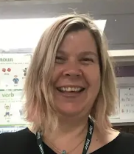 | In her absence |  | 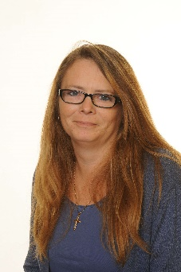 | 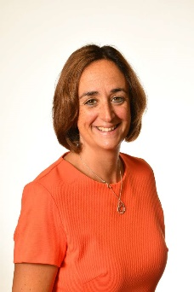 | 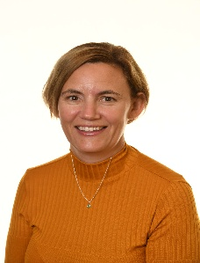
Ms F Dowley  Head Teacher |  | Mr J Terrill  Deputy Head Teacher | Ms N Palethorpe  SENDCO/SSC | Ms K Brayne  Pastoral Lead | Mrs S Stalker  School Business Manager
What to do if you are worried that a child is being abused or likely to be abused:
- Write down your concerns and what has made you concerned. Use a ‘Pupil Concern Sheet’ (copies outside Head Teacher office) or use any paper that is to hand. Treat all discussions/ notes as confidential
- Contact Designated Safeguarding Lead (DSL) for advice and show them your notes as soon as practical
- If you feel it is urgent and are unable to contact DSL or feel your concerns are not being acted upon appropriately then contact the Integrated Front Door (IFD) directly
Before a child will make a disclosure they must feel secure, feel that there is an adult whom they can approach in school and that they will be listened to. Is this the case for all our pupils? Are there any pupils who could be vulnerable because they do not feel secure at school, there is not an adult they can approach or because they do not feel listened to? Do you feel pupils are vulnerable for other reasons (poor speech/language/ability to articulate? Poor attendance? Low cognitive abilities?) If yes – take action!
What to do if a disclosure is made to you:
If child is speaking freely, listen carefully. If possible write down verbatim some of what is said, then or soon after. Use a ‘Pupil Concern Sheet’ (copies outside Head Teacher office) or use any paper that is to hand.
- Don’t promise confidentiality to the child. Try not to ask leading questions of the child
- Unless there is an immediate safeguarding issue, don’t take any action that may demonstrate your concern at the situation: it is important remain calm
- If you feel it is urgent you must ensure that a DSL is made aware of your concern as soon as possible
- If the allegations refer to a member of staff, please contact the DSL in the first instance. If the allegation refers to the Head teacher then contact the Local Authority Designated Officer (LADO) or Chair of Governors
In any notes, (treat all notes/discussions as confidential) ensure that you identify:
The specific reason for the concern What was said or witnessed by whom
Dates and times of any identified incidents Date and time when notes were made
In any case if you feel your concerns have not been acted on you can report directly to MASH or to LADO
IFD: Telephone: 01403 229 900 Out of Hours: 0330 222 6664 Email: WSChildrenservices@westsussex.gov.uk
LADO Telephone number: 0330 222 6450 (out of hours call IFD) Email: LADO@westsussex.gov.uk

