Meet our Young Carers team

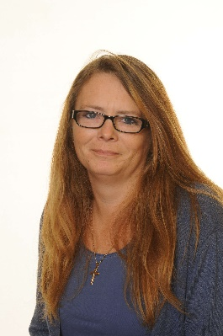 Ms Palethorpe - Young Carers Lead

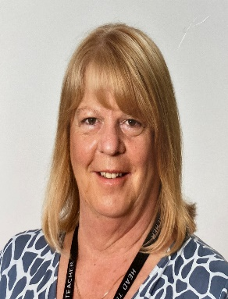 Mrs Langtree – Operational Lead

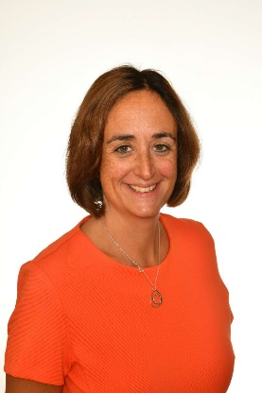 Ms Brayne – Pastoral team

