
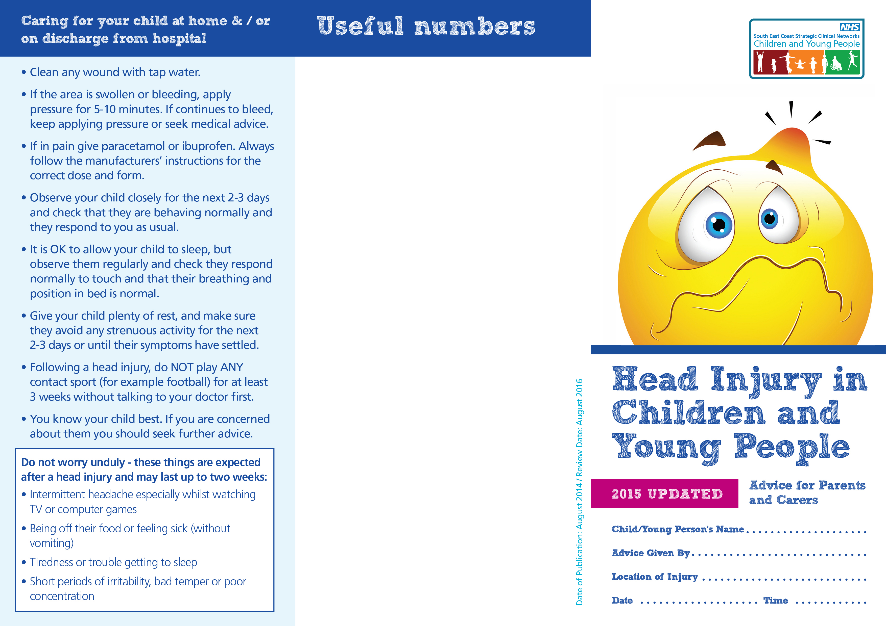

Hospitals with Emergency Departments:
Royal Alexandra Children’s Hospital
Eastern Road, Brighton BN2 5BE
Princess Royal Hospital
Lewes Road, Haywards Heath RH16 4EX
Surrey and Sussex Healthcare NHS Trust
East Surrey Hospital, Canada Ave, Redhill, Surrey RH1 5RH
Western Sussex Hospitals NHS Foundation Trust
including:
St Richards Hospital, Spitalfield Lane, Chichester PO19 6SE
Worthing Hospital, Lyndhurst Rd, Worthing BN11 2DH
Minor Injuries Units (MIU) or Urgent Care Centres
Bognor Regis War Memorial Hospital - Minor Injuries
Unit, Shripney Road, Bognor Regis, PO22 9PP
Open 9am- 5pm, Monday – Friday (excluding bank holidays)
Crawley Urgent Treatment Centre
Crawley Hospital, West Green Drive, Crawley RH11 7DH
Open 24 hours, 7 days a week
Horsham Minor Injuries Unit
Horsham Hospital, Hurst Rd, Horsham RH12 2DR
Open 9am- 5pm, Monday – Friday (excluding bank holidays)
Queen Victoria Hospital Minor Injuries Unit (MIU),
East Grinstead
Holtye Road, East Grinstead RH19 3DZ
Open 8am- 10pm, 7 days a week
West Sussex - Family Information Service
Tel: 01243 777807 www.westsussex.gov.uk/family
For more copies of this document, for more information
and to feedback, please email us:
Chichester/Worthing area: contactus.coastal@nhs.net
Crawley area: CCCG.contactus-crawleyccg@nhs.net
Horsham/Mid Sussex area:
HSCCG.contactus-horshamandmidsussexccg@nhs.net

