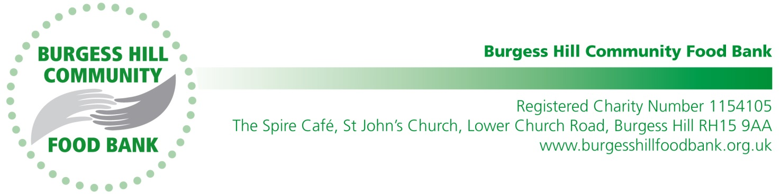

Mrs N Langtree
Head Teacher
London Meed School
Chanctonbury Road
Burgess Hill
West Sussex RH15 9YQ
14 March 2023

Dear Mrs Langtree

Donation

Thank you very much to all the children and staff at London Meed School for your generous donation of £126.33 from your Christmas Carol Service collection to the Burgess Hill Community Foodbank.

Your assistance will help the Foodbank to continue with its valuable work.

You can find further information about our work on our website www.burgesshillfoodbank.org.uk

Thank you again for your donation.

Yours sincerely,
Amanda Green

Amanda Green
On behalf of the Burgess Hill Community Foodbank

